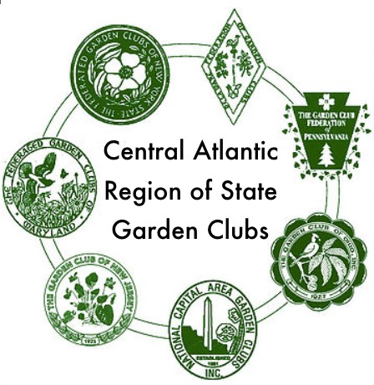
Central Atlantic Region
of State Garden Clubs
AWARDS APPLICATION 2023-2025

Award Name: Award Number (if applicable)

Submitted by Number of Members in Club: (Enter name exactly as it should appear on any award received.)

Name of State Garden Club: Number in State Garden Club: State Awards Chairman: Cheryl Kopyt Phone:315-839-6219 Email: thekopyts25@gmail.com
CAR-SGC Awards Chairman: Mary Noel Phone:302-337-1054 Email: mhnoel@earthlink.net

Any club or member affiliated with CAR-SGC may apply for an award from the region, even if that award category is not included in the options for your state awards. You may use this application to apply for a
CAR-SGC award but your application must be submitted to your state award chairman. Your application will not be considered for a region award unless it is submitted by your state award chairman to the CAR-SGC award chairman that is designated in the description for that award.
State awards chairmen must send all CAR-SGC award applications to the designated chairman for the award, as listed in the Awards Rules.
CAR-SGC award applications are limited to this form as a cover sheet and three printed pages, front of pages only. (No report cover or binders allowed, no plastic sheets are allowed.)
PLEASE complete each topic, if applicable. Use numbering as below when completing form.
- New Project: YES NO Beginning date: Completion date:
- Brief summary and objectives of project
- Involvement of club members, other organizations, etc.
- Project expenses and means of funding.
- Continuing involvement, follow-up, maintenance
- Attach or insert photos, digital photos and/or landscape plan (does not need to be professionally drawn).
Application form will not be returned. (Exception: For publicity press books, please include a self-addressed stamped envelope for return.)

DEADLINES:
- January 15 — National Awards with Region Judging (currently only the Member of Honor Award)
- February 1 — Youth Poetry, Youth Sculpture and Smokey Bear/Woodsy Owl posters
- March 1 — High School Essay
- April 1 — All other award applications

CAR-SGC Awards Application Rev. 7/23/2023

